**Machine Learning – Lecture Notes – Part II**

**Week 4**

**Neural Networks: Representations**

**Motivations**

Non-Linear Hypotheses

* In many different types of problems, complex non-linear hypothesis are needed – often those that can’t be modelled by linear/logistic regression.

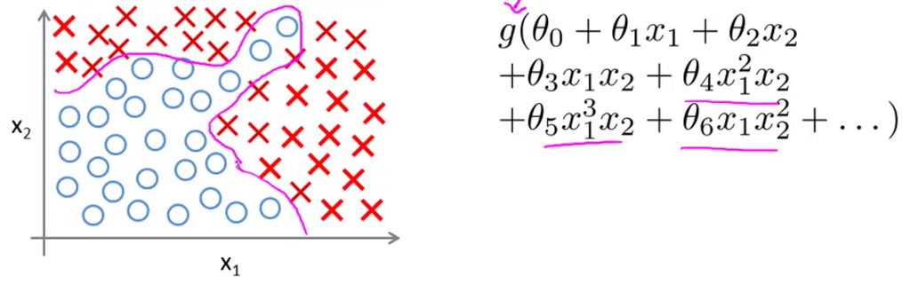

* In the example above, the decision boundary could be modelled with polynomial features, but it would require a lot to accurately represent the boundary.
* Now let’s look at the problem of computer vision. When you look at an image of car, you can easily recognize that the object is a car. For a camera, however, it sees a very large matrix of numbers.
* Concretely, when we train a classifier like this, we must give the algorithm many images of cars and not cars.
* In a 50 by 50px image, there are 2500 pixels. Thus, if we used a non-linear hypothesis on this set, it would require at least 2500 features. If we used quadratic terms, this would require about 3 million features, which is very computationally expensive.

Neurons and the Brain

* Neural networks originated as algorithms that tried to mimic the brain.

**Neural Networks**

Model Representation I

* Here are some of the different parts of a neuron in a brain.

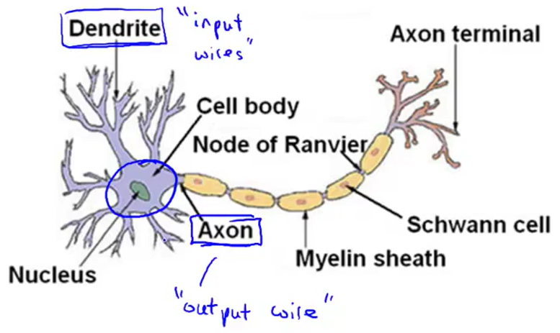

* In an artificial neural network, each neuron is treated as a **logistic unit**.

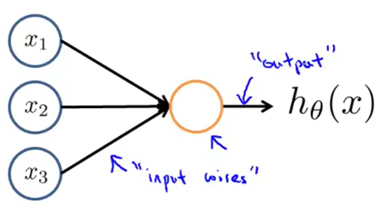

* The “bias unit” is called the feature $x_{0}$ because it always equals $1$.
* Each logistic unit performs some calculation $h_{θ}\left(x\right)$ given a set of inputs. That calculation is the (sigmoid) logistic function performed on the inputs.
$$h_{θ}\left(x\right)=\frac{1}{1+e^{-θ^{T}x}}$$

* The sigmoid function is the **activation function**. In neural networks, the parameters $θ$ are often referred to as the **weights** of the function.
* A neural network is a group of neurons strummed together, as shown below.

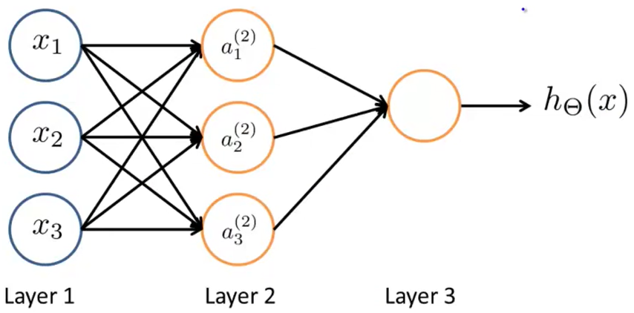

* For more neural network terminology, the first layer is called the **input layer**. It is where the inputs are put in to a network.
* The final layer is the **output layer**. Then, layer 2 or any middle layer is called a **hidden layer**, because its computation is hidden from the user.
* Here is some notation specific to neural networks.
  + $a_{i}^{\left(j\right)}$ = “activation” of unit $i$ in layer $j$
  + $Θ^{\left(j\right)}$ = matrix of weights controlling function mapping from layer $j$ to layer $j+1$
* In the neural network shown in the picture above, each term is computed as shown.

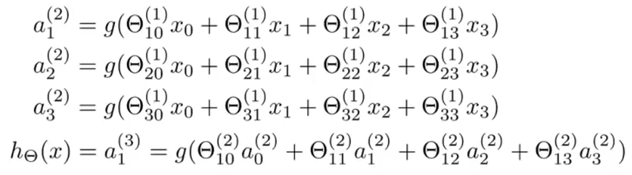

* In this case, our $Θ^{\left(1\right)}∈R^{3×4}$, since it contains the 0th mapping ($x_{0}=1$) and 3 other mappings and 3 elements.
* In general, if a network has $s_{j}$ units in layer $j$ and $s_{j+1}$ units in layer $j+1$, then $Θ^{\left(j\right)}$ has dimensions $s_{j+1}×\left(s_{j}+1\right)$.

Model Representation II

* Let’s look at a vectorized implementation of a neural network.

$$z^{\left(2\right)}=Θ^{\left(1\right)}x=Θ^{\left(1\right)}a^{\left(1\right)}$$

$$a^{\left(2\right)}=g\left(z^{\left(2\right)}\right)$$

* Since the input layer $a^{\left(1\right)}$ contains the set of inputs, we can set $x=a^{\left(1\right)}$.
* For the next layer (output layer), add $a_{0}^{\left(2\right)}=1$. Then you can do the following.
$$z^{\left(3\right)}=Θ^{\left(2\right)}a^{\left(2\right)}$$

$$h_{Θ}\left(x\right)=a^{\left(3\right)}=g\left(z^{\left(3\right)}\right)$$

* This process of computing each layer is called **forward propagation**.
* In general, we have the two steps for each layer in the neural network. The first computes the linear combination of weights and the inputs from the last layer. Then, the we get the activation nodes of layer $j$ as follows.

$$z^{\left(j\right)}=Θ^{\left(j-1\right)}a^{\left(j-1\right)}$$

$$a^{\left(j\right)}=g\left(z^{\left(j\right)}\right)$$

**Applications**

Examples and Intuitions I

* For the AND function, the two inputs $x_{1},x_{2}∈\left\{0, 1\right\}$ determine the output $y=x_{1} AND x_{2}$.
* In this case, we’ll have
* Let’s look at an example where a neural network is used to create a hypothesis. Our example function will be the XOR/XNOR function (exclusive-or/nor) function. It is an abstraction of a more complex problem.
* This problem involves binary classification.
* Let’s say we have the following network then. Since there 2 inputs, there will 3 input nodes ($x_{0}=1$, $x_{1}$, and $x_{2}$).

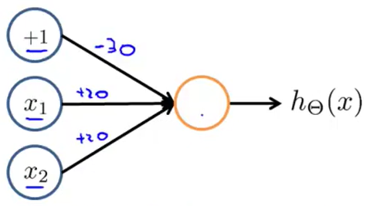

* The numbers on the lines represent the “weight” assigned to them, which is just a heuristic. It comes from the values of matrix $Θ$.
$$Θ_{1}^{\left(1\right)}=\left[\begin{aligned}-30 \\ 20 \\ 20\end{aligned}\right]$$

* Then, the hypothesis function becomes the following.
$$h_{Θ}\left(x\right)=g\left(-30+20x_{1}+20x_{2}\right)$$

* So now let’s test the hypothesis with values of $x_{1},x_{2}$.

|  |  |  |
| --- | --- | --- |
| $$x_{1}$$ | $$x_{2}$$ | $$h_{Θ}\left(x\right)$$ |
| 0 | 0 | $$g\left(-30\right)≈0$$ |
| 0 | 1 | $$g\left(-30+20\right)=g\left(-10\right)≈0$$ |
| 1 | 0 | $$g\left(-30+20\right)=g\left(-10\right)≈0$$ |
| 1 | 1 | $$g\left(-30+40\right)=g\left(10\right)≈1$$ |

* If you look at this, this is exactly the logical AND function.
$$h_{Θ}\left(x\right)≈x_{1} AND x_{2}$$

* Here’s another example: the OR function.

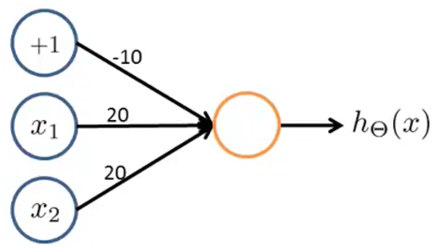

* This can be verified using a truth table like above.

|  |  |  |
| --- | --- | --- |
| $$x_{1}$$ | $$x_{2}$$ | $$h_{Θ}\left(x\right)$$ |
| 0 | 0 | $$g\left(-10\right)≈0$$ |
| 0 | 1 | $$g\left(-10+20\right)=g\left(10\right)≈1$$ |
| 1 | 0 | $$g\left(-10+20\right)=g\left(10\right)≈1$$ |
| 1 | 1 | $$g\left(-10+40\right)=g\left(30\right)≈1$$ |

Examples and Intuitions II

* We can also have a network to compute the negation of an element $x_{1}$, written as $NOT x_{1}$.

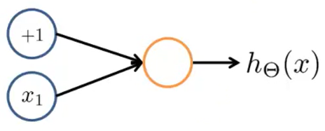

* Since there is only 1 input $x_{1}$, there are only 2 nodes in the input layer. Now we need to decide the weights/heuristics/parameters $Θ$.
* Let’s say $Θ_{10}^{\left(1\right)}=10$ and $Θ_{11}^{\left(1\right)}=-20$. Then, the hypothesis is $h_{Θ}\left(x\right)=g\left(10-20x_{1}\right)$. We can make a table to analyze this function.

|  |  |
| --- | --- |
| $$x_{1}$$ | $$h_{Θ}\left(x\right)$$ |
| 0 | $$g\left(10\right)≈1$$ |
| 1 | $$g\left(10-20\right)=g\left(-10\right)≈0$$ |

* Now we can put it together to form the XNOR function.

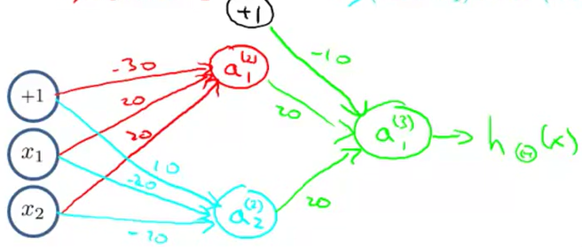

* The XNOR function outputs $1$ if $x_{1}=x_{2}=0, 1$. If $x_{1}≠x_{2}$, then $x_{1} XNOR x_{2}=0$.
* In the 3-layer neural network above, the input runs through a hidden layer which computes the $x_{1} AND x_{2}$ and $\left(NOT x_{1}\right) AND \left(NOT x_{2}\right)$ functions. Then, it computes the $x_{1} OR x_{2}$ function in the output layer.
* This is shown by the table below.

|  |  |  |  |  |
| --- | --- | --- | --- | --- |
| $$x_{1}$$ | $$x_{2}$$ | $$a_{1}^{\left(2\right)}→AND$$ | $$a_{2}^{\left(2\right)}→NAND$$ | $$h_{Θ}\left(x\right)→XNOR$$ |
| 0 | 0 | 0 | 1 | **1** |
| 0 | 1 | 0 | 0 | **0** |
| 1 | 0 | 0 | 0 | **0** |
| 1 | 1 | 1 | 0 | **1** |

Multiclass Classification

* What if there’s more than 1 category we’re trying to create a decision boundary for? The handwritten digits recognition problem is a multiclass classification problem because there are 10 categories for recognizing a digit (0–9).
* This problem is an extension of the **one-vs-all** method. For example, when you’re trying to recognize multiple objects – pedestrian, car, motorcycle, and truck, you can build 4 different cases of $h_{Θ}\left(x\right)$.

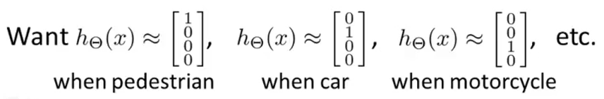

* Thus, the function $h_{Θ}\left(x\right)∈R^{4}$. The entire setup of our neural network looks like the following.

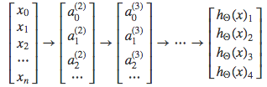

* Whichever class $h_{Θ}\left(x\right)$ falls into is what is recognized by the neural network. For each $x_{i}$ for $1<i≤n$, $x_{i}$ is an input image.
* Then, the output vector $y$ falls into one of the $n$ categories.

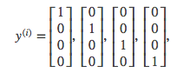

**Week 5**

**Neural Networks: Learning**

**Cost Function and Back Propagation**

Cost Function

* Here we’ll focus on the application of neural networks on classification problems.

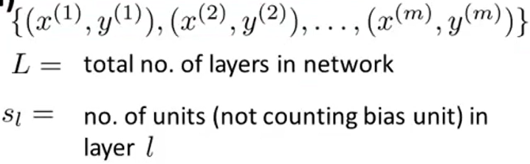

* There are two types of classification problems to consider.

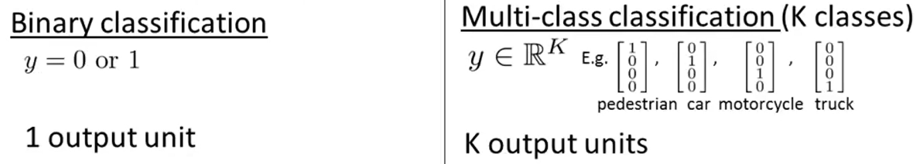

* Now let’s define a cost function for the neural network. The following is the cost function of the logistic regression.
$$J\left(θ\right)=-\frac{1}{m}\left[\sum_{i=1}^{m}{y^{\left(i\right)}\log{h_{θ}\left(x^{\left(i\right)}\right)}+\left(1-y^{\left(i\right)}\right)\log\left(1-h_{θ}\left(x^{\left(i\right)}\right)\right)}\right]+\frac{λ}{2m}\sum_{i=1}^{m}{θ_{j}^{2}}$$

* Here’s the cost function for a neural network.
$$J\left(Θ\right)=-\frac{1}{m}\left[\sum_{i=1}^{m}{\sum_{k=1}^{K}{y_{k}^{\left(i\right)}\log{h_{Θ}{\left(x^{\left(i\right)}\right)}_{k}}+\left(1-y_{k}^{\left(i\right)}\right)\log\left(1-{\left(h_{Θ}\left(x^{\left(i\right)}\right)\right)}_{k}\right)}}\right]+\frac{λ}{2m}\sum_{l=1}^{L-1}{\sum_{i=1}^{s_{l}}{\sum_{j=1}^{s_{l}+1}{{\left(Θ_{ji}^{\left(l\right)}\right)}^{2}}}}$$

* To minimize $J\left(Θ\right)$, we need to compute both $J\left(Θ\right)$ and $\frac{∂}{∂Θ_{ij}^{(l)}}J\left(Θ\right)$, the partial derivatives of the cost function.

Backpropagation Algorithm

* We see that in forward propagation we can use the following algorithm for computing the output of 1 training example $(x,y)$.
$$a^{\left(1\right)}=x \\ z^{\left(2\right)}=Θ^{\left(1\right)}a^{\left(1\right)}$$

$$a^{\left(2\right)}=g\left(z^{\left(2\right)}\right) , add a_{0}^{\left(2\right)}$$

$$z^{\left(3\right)}=Θ^{\left(2\right)}a^{\left(2\right)}$$

$$a^{\left(3\right)}=g\left(z^{\left(3\right)}\right) , add a_{0}^{\left(2\right)}$$

$$z^{\left(4\right)}=Θ^{\left(3\right)}a^{\left(3\right)}$$

$$a^{\left(4\right)}=h_{Θ}\left(x\right)=g\left(x\right)=g\left(z^{\left(4\right)}\right)$$

* The error on each activation node is given by $δ_{j}^{\left(l\right)}$, where j is the number of nodes in, and can be computed as follows. (For $l>1$ because $l=1$ represents the input layer: the features that the model has learned.)
$$δ^{\left(l\right)}={\left(Θ^{\left(l\right)}\right)}^{T}δ^{\left(l+1\right)}.*g^{'}\left(z^{\left(l\right)}\right)={\left(Θ^{\left(l\right)}\right)}^{T}δ^{\left(l+1\right)}.*\left(a^{\left(l\right)}.*\left(1-a^{\left(l\right)}\right)\right)$$

* Where $.*$ represents element-wise multiplication. Back-propagation refers to the error terms $δ_{j}^{\left(l\right)}$ that are being sent backwards after computing the output layer.

Backpropagation Algorithm Method

* Given training set $\left\{\left(x^{\left(1\right)},y^{\left(1\right)}\right),…,\left(x^{\left(m\right)},y^{\left(m\right)}\right) \right\}$
* We then set $Δ_{ij}^{\left(l\right)}=0$ for all $l,i,j$
* For $i=1$ to $m$:
  + Set $a^{(1)}=x^{\left(i\right)}$
  + Repeat for $a^{\left(l\right)}$ for $l=2, 3,…,L$
  + Using $y^{\left(i\right)}$ compute $δ^{\left(L\right)}=a^{\left(L\right)}-y^{\left(i\right)}$
  + Compute $δ^{\left(L-1\right)},δ^{\left(L-2\right)},…,δ^{\left(2\right)}$
  + $Δ_{ij}^{\left(l\right)}≔Δ_{ij}^{\left(l\right)}+a_{j}^{\left(l\right)}δ_{i}^{\left(l+1\right)}$ (Vectorized implementation: $Δ_{ij}^{\left(l\right)}≔Δ_{ij}^{\left(l\right)}+δ^{\left(l+1\right)}{\left(a^{\left(l\right)}\right)}^{T}$.)
* $D_{ij}^{\left(l\right)}≔\frac{1}{m}\left(Δ_{ij}^{\left(l\right)}+λΘ_{ij}^{\left(l\right)}\right)$ (if $j≠0$)
* $D_{ij}^{\left(l\right)}≔\frac{1}{m}Δ_{ij}^{\left(l\right)}$ (if $j=0$)
* We see that $\frac{∂}{∂Θ_{ij}^{\left(l\right)}}J\left(Θ\right)=D_{ij}^{\left(l\right)}$

**Backpropagation Intuition**

* Forward propagation computes the

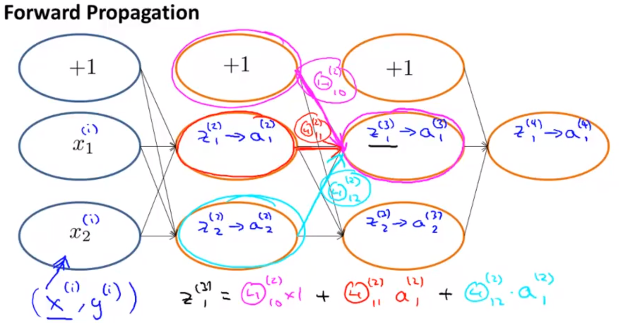

* The cost function then calculates the difference between the output value of that node and the actual value. One example of a cost function is a squared difference function, but we usually use the logarithmic cost function instead.
* Backpropagation computes the error terms $δ_{j}^{\left(l\right)}$ for each activation $a_{j}^{\left(l\right)}$ (unit $j$ in layer $l$). Formally, $δ_{j}^{\left(l\right)}=\frac{∂}{∂z_{j}^{\left(l\right)}}\operatorname{cost}\left(i\right)$, where $z_{j}^{\left(l\right)}$ is the sum of the values and weights of previous nodes (an intermediate calculation before computing the activation on this node).
* Once all the activations have been calculated, we can find the error terms at each node. The error term is a weighted sum of the errors in previous nodes.

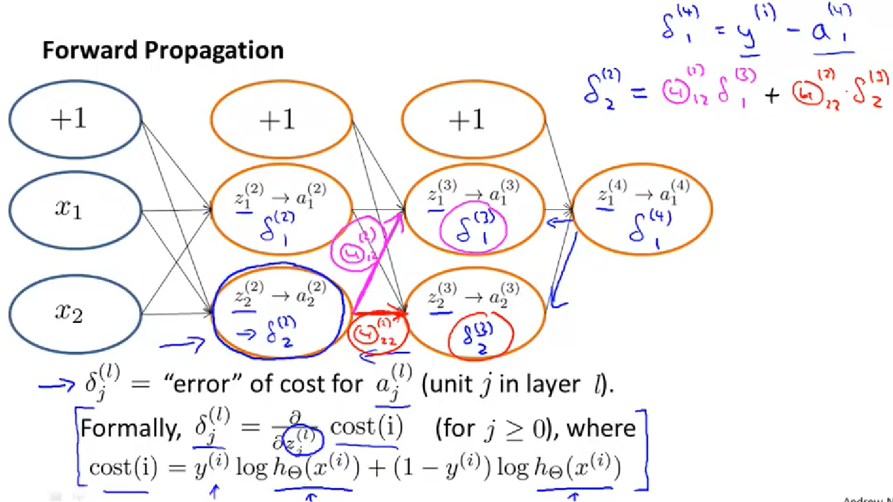

**Backpropagation in Practice**

**Implementation Note: Unrolling Parameters**

* When using linear or logistic regression, we had our cost function and gradient (partial derivative) terms as vectors in $R^{n+1}$.

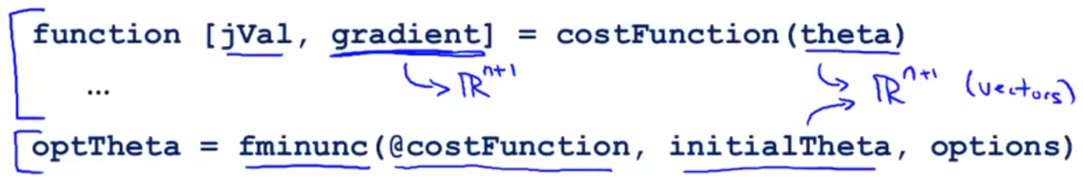

* However, we now have them as matrices in a neural network. We must “unroll” these matrices into vectors to pass them into the cost and advanced optimization functions.
* We can unroll them by the following command.



* We can also reshape the vectors into matrices by using the reshape method.

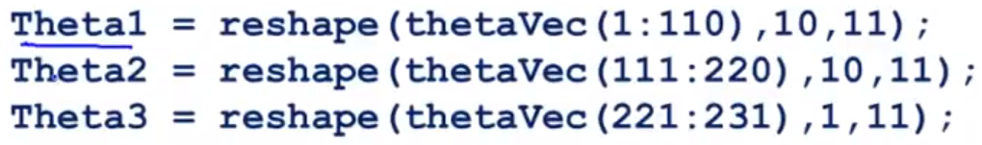

* In the learning algorithm, we must “unroll” a few parameters. We must unroll the initialTheta variable to use advanced optimization methods like fminunc.
* Also, we have to unroll $D^{\left(1\right)},D^{\left(2\right)},D^{\left(3\right)}$ to get gradientVec, the parameter to pass into the cost function (for forward and back propagation).

Numerical Estimation of Gradients

* Sometimes to check that we are computing partial derivatives correctly, we can estimate the slope using:
$$\frac{d}{dθ}J\left(θ\right)≈\frac{J\left(θ+ε\right)-J\left(θ-ε\right)}{2ε}$$

* For some $ε≈{10}^{-4}$.

Parameter Vector $θ$

* Firstly, we have $θ∈R^{n}$ because $θ$ is an unrolled version of $Θ^{\left(1\right)},Θ^{\left(2\right)},Θ^{\left(3\right)}$.
* We can then approximate each of the error terms of the partial derivatives.

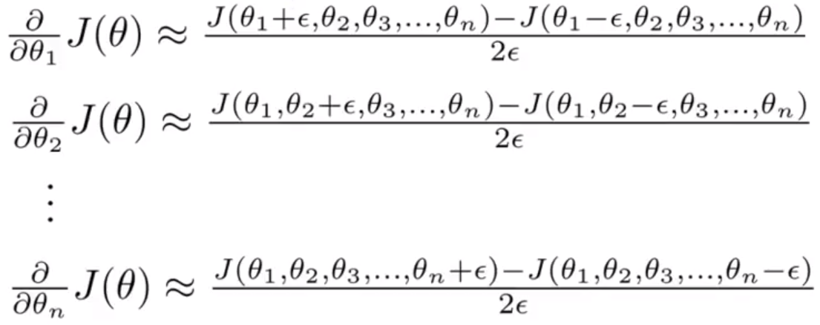

* We implement this using the following method.

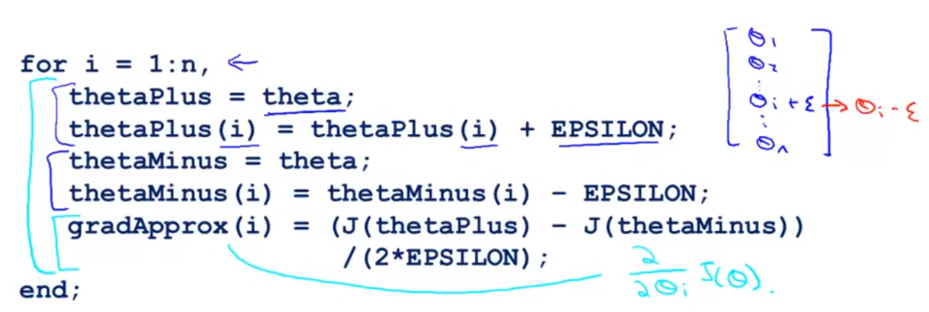

* Then, after computing gradApprox, we check if $gradApprox≈DVec$.

**Random Initialization**

* For our algorithms, we need to pick some initial value of $Θ$.
* However, we cannot simply pick $Θ_{ij}^{\left(l\right)}=0$ for all $i,j,l$. What ends up happening is that after each gradient descent step, the values of $Θ_{ij}^{\left(l\right)}$ would be all the same for the layer $i$. This is because the weights start off as identical.
* This means that the activations are all the same for a layer and your neural network is only really computing 1 feature of the problem, which is quite redundant.

Random Initialization: Symmetry Breaking

* Initialize each $Θ_{ij}^{\left(l\right)}$ to a random value in $\left[-ε,ε\right]$. In MATLAB/Octave, we can do this using the code.

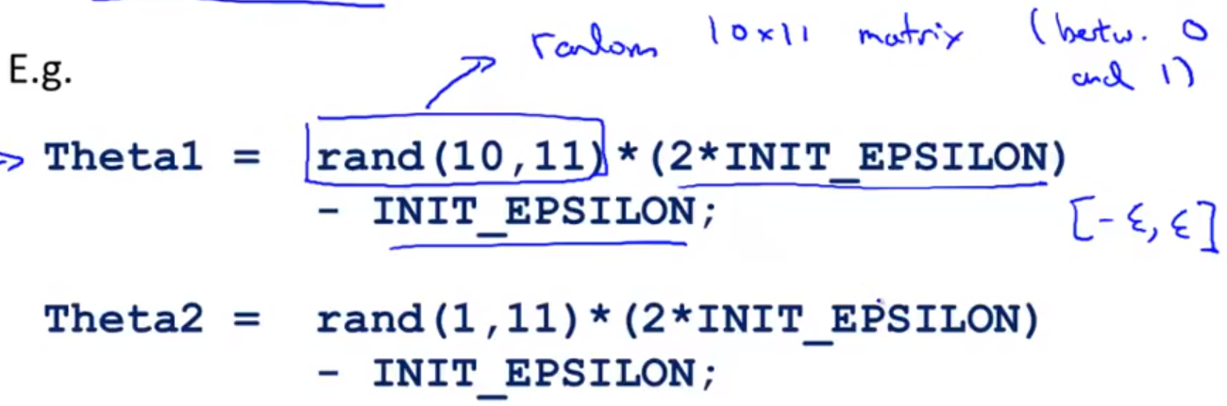

**Putting It Together**

* First, we pick a network architecture.
  + No. of input units: dimension of features $x^{\left(i\right)}$
  + No. of output units: number of classes
  + Reasonable default: 1 hidden layer, or if > 1 hidden layer, have same no. of hidden units in each layer (usually the more the better)
* Then, we do the following steps
  1. Randomly initialize weights (within $ε$ of $0$)
  2. Implement forward propagation to get $h_{Θ}\left(x^{\left(i\right)}\right)$ for any $x^{\left(i\right)}$
  3. Implement code to compute cost function $J\left(Θ\right)$
  4. Implement backpropagation to get partial derivatives $\frac{∂}{∂Θ_{jk}^{\left(l\right)}}J\left(Θ\right)$

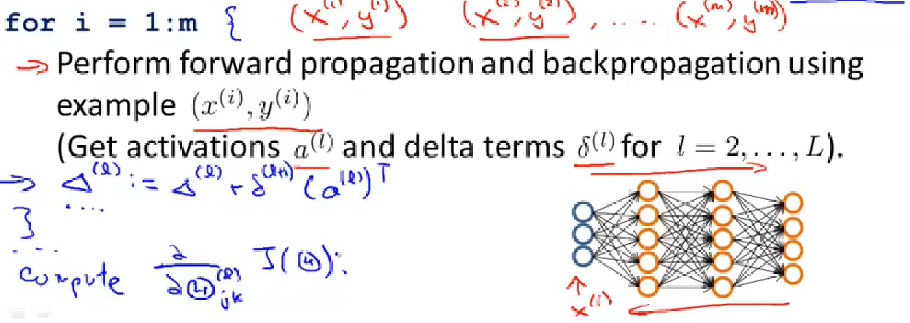

* For each training example, we accumulate the delta terms to get the partial derivatives at the end, which we compute outside the for loop.
  1. Use gradient checking to compare $\frac{∂}{∂Θ_{jk}^{\left(l\right)}}J\left(Θ\right)$ computed using backpropagation vs. numerical estimation (then turn off gradient checking)
  2. Use gradient descent or advanced optimization techniques (e.g. fminunc) with backpropagation to minimize of $J\left(Θ\right)$ as a function of $Θ$
* We see that this is what is happening to the values of the parameters.

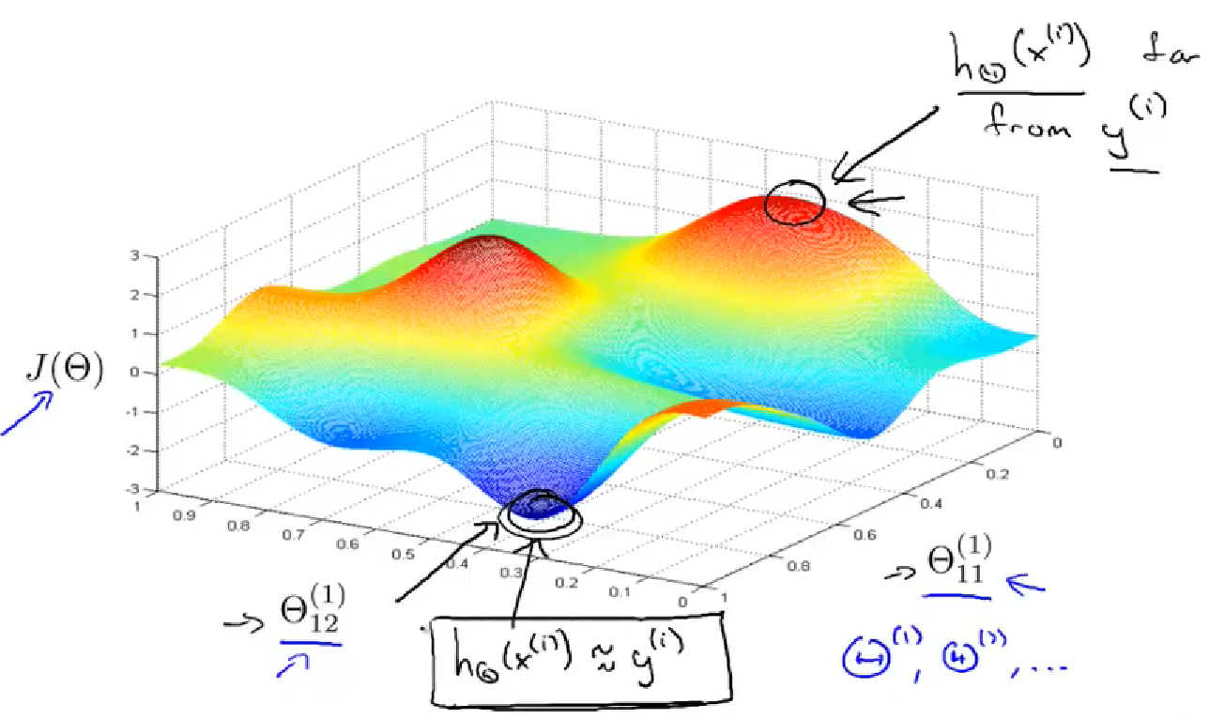

**Week 6**

**Deciding What to Try Next**

Debugging a Learning Algorithm

* Let’s say you’ve learned housing prices from data using a logistic regression model.
$$J\left(θ\right)=\frac{1}{2m}\left[\sum_{i=1}^{m}{{\left(h_{θ}\left(x^{\left(i\right)}\right)-y^{\left(i\right)}\right)}^{2}}+λ\sum_{j=1}^{m}{θ_{j}^{2}}\right]$$

* If there are unacceptably large errors in prediction, what do you try next?
  + Get more training examples
  + Try smaller set of features (to prevent overfitting)
  + Try getting additional features (maybe there are hidden relationships)
  + Try adding polynomial features ($x_{1}^{2},x_{2}^{2}, x_{1}x_{2}$, etc.)
  + Try increasing/decreasing $λ$
* Machine learning diagnostic: A test to run to gain insight on what is/isn’t working with a learning algorithm and gain guidance on how to improve performance.

Evaluating a Hypothesis

* One way to evaluate a hypothesis to see overfitting, for example, is to split the data into a training (70%) and testing (30%) sets.
* If there is any order to the data, it is better to randomly send 70% to the training set and 30% to the testing set.
* Basically, you learn parameters $θ$ from your training set (minimizing cost $J\left(θ\right)$) and compute the test error on the testing set. The following is the cost function on a linear regression model.
$$J_{test}\left(θ\right)=\frac{1}{2m_{test}}\sum_{i=1}^{m_{test}}{{\left(h_{θ}\left(x_{test}^{\left(i\right)}\right)-y_{test}^{\left(i\right)}\right)}^{2}}$$

* Training/testing procedure for a logistic regression model:
  + Learn parameters $θ$ from training data
  + Compute test set error
 $$J\left(θ\right)=-\frac{1}{m_{test}}\sum_{i=1}^{m_{test}}{y_{test}^{\left(i\right)}\log\left(h_{θ}\left(x_{test}^{\left(i\right)}\right)\right)+\left(1-y_{test}^{\left(i\right)}\right)\log\left(h_{θ}\left(x_{test}^{\left(i\right)}\right)\right)}$$

 + There is another way called misclassification error (0/1 classification error)
 $$\operatorname{err}\left(h_{θ}\left(x\right),y\right)=\left\{\begin{matrix}1, if h_{θ}\left(x\right)≥0.5, y=0 or if h_{θ}\left(x\right)<0.5 and y=1 \\ 0, else\end{matrix}\right.$$

 + We then define the cost function to be

$$J\left(θ\right)=\frac{1}{m_{test}}\sum_{i=1}^{m_{test}}{\operatorname{err}\left(h_{θ}\left(x_{test}^{\left(i\right)}\right),y_{test}^{\left(i\right)}\right)}$$

**Model Selection and Train/Validation/Test Sets**

* In the case of fitting a polynomial function of degree $n$ to your training data, deciding $n$ is like another parameter in your parameter vector $θ$.

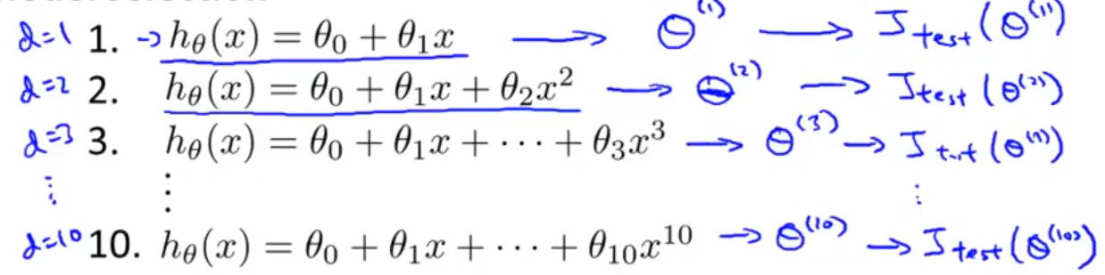

* After finding all the parameters for all the polynomials, we could see which polynomial degree yields the lowest *test* error.
* However, this is likely an optimistic estimate of generalization error. I.e. our extra parameter ($d=degree of polynomial$) is fit to the test set, since the degree is chosen based on the test set.
* Thus, the polynomial would likely do worse on new examples.
* To evaluate our hypothesis polynomial better, we now split data set into 3 pieces: **training set** (60%), **cross-validation set** (20%), and **test set** (20%).
* Thus, we split our errors into 3 pieces (training error, cross-validation error and test error).
* We then train our model on our **test set** to produce a set of parameters $θ$, and we can test this on the **cross-validation set** (new examples that haven’t been seen before).

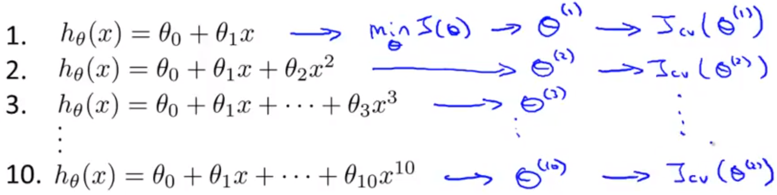

* For argument, let’s say it is the 4th order polynomial $θ_{0}+θ_{1}x+…+θ_{4}x^{4}$. We estimate generalization error for test set as $J_{test}\left(θ^{\left(4\right)}\right)$.
* This will be much more accurate representation of generalization error.
* Three simple steps:

1. Optimize the parameters in Θ using the training set for each polynomial degree.
2. Find the polynomial degree d with the least error using the cross validation set.
3. Estimate the generalization error using the test set with *Jtest*(Θ(*d*)), (d = theta from polynomial with lower error);

Diagnosing Bias vs. Variance

* When you have a bad learning model, you could have a bias (underfitting) or variance (overfitting) problem in your model.
* To analyse the bias/variance in a data set, we first train our model on the training set. When we plot the error of the function on the training set as a function of the degree of the polynomial used, we find the error rapidly decreases because the higher degree polynomials can overfit the data.
* We then look at the cross-validation set error (or test set error). We get the following graph.

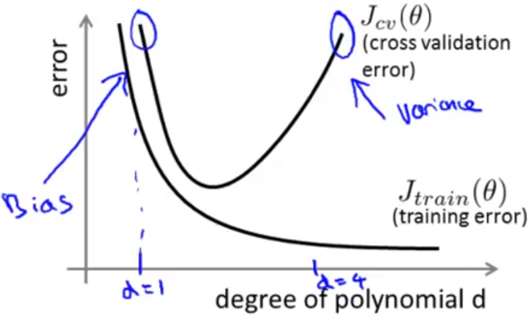

* For a bias problem, we have
  + High $J_{train}\left(θ\right)$
  + High $J_{CV}\left(θ\right)$ ($J_{CV}\left(θ\right)≈J_{train}\left(θ\right)$)
* For a variance problem, we have
  + High $J_{train}\left(θ\right)$
  + Low $J_{CV}\left(θ\right)$ ($J_{CV}\left(θ\right)≫J_{train}\left(θ\right)$)

**Regularization and Bias/Variance**

* The regularization cost for the model can also affect how much bias/variance is present. If the value of $λ$, the regularization cost, is too high, then the parameters $θ$ will be heavily penalized and will end up with values close to 0 (so end up with constant model).
* Thus, we get clearly underfit model for the data.
* If we choose a very small value of $λ$, we get overfitting because the learned parameters are not penalized.
* An intermediate value of $λ$ should yield a relatively accurate model.
* When we define the error on our training and testing and cross-validation sets, we leave out the regularized term for the parameters $θ$.

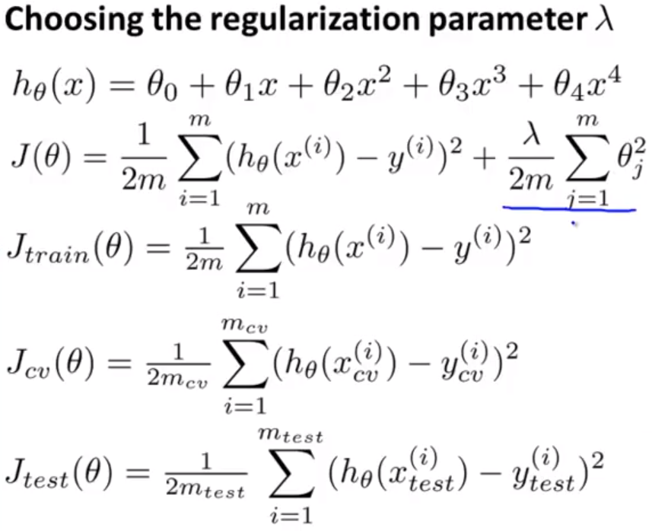

* To find the best regularization term, we take different values of $λ$ and find the minimum cost $J\left(θ\right)$ under those conditions. Then, we cross-validate these parameters using the CV set and pick the model that yields lowest $J_{CV}\left(θ\right)$.

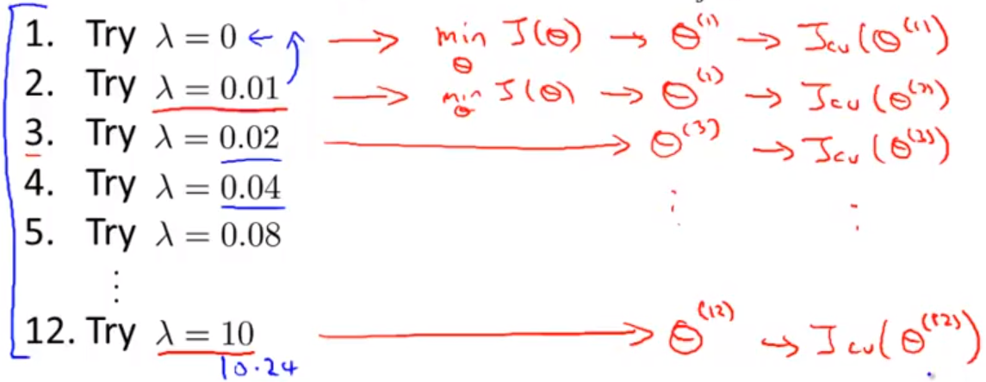

* Finally, we report the test error of the model $J_{test}\left(θ^{\left(n\right)}\right)$, where the $n^{th}$ model has the lowest cross-validation error.
* When we plot error as a function of the “parameter” $λ$, we get the following.
  + For small $λ$, parameters are not punished, so variance is high, and data is overfitted.
  + For large $λ$, parameters are heavily punished, so bias is high, and data is underfitted.

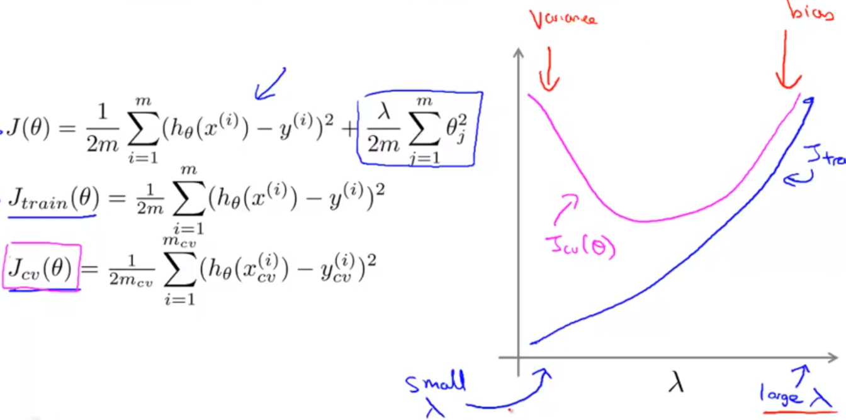

* We want to find the $λ$ that minimizes $J_{CV}\left(θ\right)$.
* Here are the key steps:

1. Create a list of lambdas (i.e. λ∈{0,0.01,0.02,0.04,0.08,0.16,0.32,0.64,1.28,2.56,5.12,10.24});
2. Create a set of models with different degrees or any other variants.
3. Iterate through the *λ*s and for each *λ* go through all the models to learn some Θ.
4. Compute the cross validation error using the learned Θ (computed with λ) on the *JCV*(Θ) **without** regularization or λ = 0.
5. Select the best combo that produces the lowest error on the cross validation set.
6. Using the best combo Θ and λ, apply it on *Jtest*(Θ) to see if it has a good generalization of the problem.

**Learning Curves**

* When we plot the error terms on the training and cross-validation sets as a function of $m$ (# of training examples), we see that the training set error is quite low at first because the model can fit less data well.
* As the number of examples increases, so does the error.

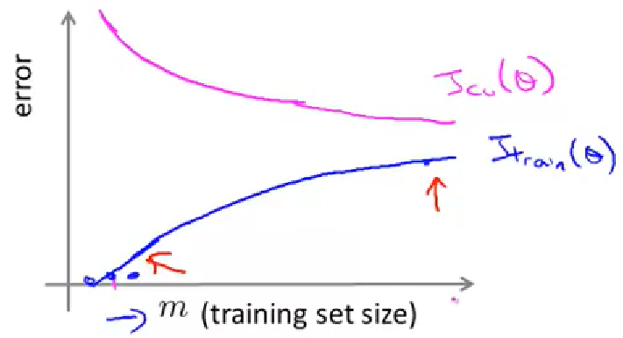

* For the cross-validation error, since a low $m$ yields a rudimentary model, it does not generalize well to new data, so the $J_{CV}\left(θ\right)$ value decreases as $m$ increases.
* We recognize high bias by seeing that the error function plateaus after a certain number of training examples.

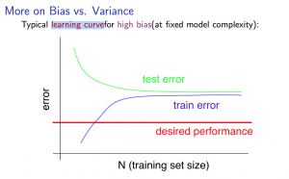

* The problem with high bias is that we end up with high error (for the $J_{CV}\left(θ\right)$ and $J_{train}\left(θ\right)$).
* Now, if we have a high variance (overfitting) problem, we see that the training error is quite low because the model can fit the data well with a high degree polynomial.
* Due to overfitting, the model performs badly on new training data, specifically $J_{CV}\left(θ\right)$ is quite high.

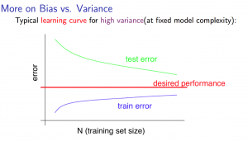

* Getting more data will help with overfitting.

**Deciding a Learning Algorithm**

* Coming back to the suggestions from the beginning, here is how they affect your data.

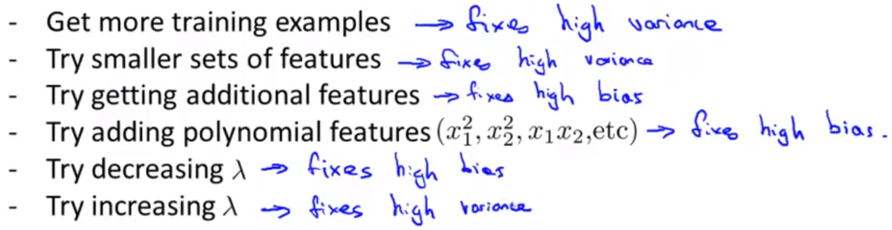

* When relating back to neural networks, there are 2 options.
  + Use a small neural network. (Fewer parameters; prone to underfitting; computationally cheaper.)

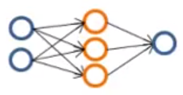

* + User a large neural network. (More parameters; prone to overfitting; computationally expensive; use regularization $λ$ to address overfitting; using a single hidden layer is a reasonable default.)

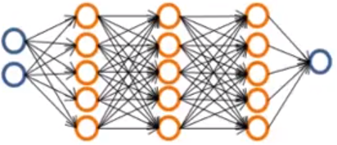

* + - To decide no. of hidden layers, use different amount of layers, calculate $J_{CV}\left(θ\right)$ after training, and take no. of hidden layers with $\min{J_{CV}\left(θ\right)}$.

**Prioritizing What to Work On**

* We can build a spam email classifier using the following technique.
  + Supervised learning. $x=$ features of email. $y=$ spam (1) or not spam (0). Features: choose 100 words indicative of spam/not spam.
  + E.g. deal, buy, discount, now, …
  + We sort these words in a vector of size 100 and label 0 if the word doesn’t appear in the email and 1 if the word appears in the email.
  + (In practice, we take the most frequently occurring $n$ words, 10,000 – 50,000, rather than manually picking 100 words.)
* To have low error, an effective way is to collect lots of data from spam emails like the “honeypot” project.
* Also, there are some other features to use.
  + Develop sophisticated features based on email routing information (from email header, email address sent from, etc.).
  + Develop features for the message body. Should “discount” and “discounts” be treated as the same word? Is the grammar and punctuation correct?
  + Develop algorithms to detect misspelled words.

**Error Analysis**

* Recommended approach to problem solving in machine learning:
  + Start with a simple algorithm, implement quickly, and test it on cross-validation data.
  + Plot learning curves to see if more data, more features, etc. are likely to help.
  + Examine errors in cross-validation set and try to spot where errors were made.
* It is important to get error results as a single numeric value. This way, we can evaluate effectiveness of learning algorithms.
* For example, if we use stemming to identify the same word, we get a 3% error rate instead of 5%, then it is worth it to switch to the stemming process.
* Otherwise, if distinguishing between upper and lower-case characters yields 3.2% error, it would not be beneficial to switch to this new feature.

**Error Metrics for Skewed Classes**

* Cancer classification example
  + Train logistic regression model $h_{θ}\left(x\right)$. Find that you get 1% error on test set (99% correct diagnoses).
  + However, if in our testing set, only 0.5% of people have cancer, this result is unimpressive. This is because we could just create a function that returns 0 always, and that would yield an error of 0.5% (better than 1%).
  + This is called a **skewed class**. When we go from 99.2% accuracy to 99.5% accuracy in a skewed class, it is hard to tell if we did something that improves the model or just randomly predicts one class more than the other.
  + There are 4 different cases of predicting data points.

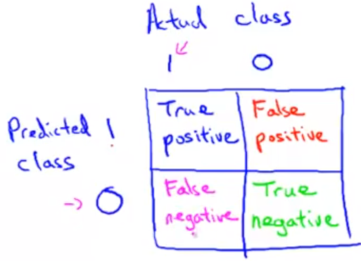

* + There are two metrics on which we evaluate performance of our classifier.
    - Accuracy – Of all patients, how many did we classify correctly?
 $$accuracy=\frac{\# of true pos+\# of true neg}{\# total examples}$$

   - Precision – Of all patients where $y=1$, what fraction has cancer?
 $$precision=\frac{\# of true pos}{\# of predicted pos}=\frac{\# of true pos}{\# of true pos+\# of false pos}$$

   - Recall – Of all patients that have cancer, what fraction did we correctly detect as having cancer?
 $$recall=\frac{\# of true pos}{\# of total pos}=\frac{\# of true pos}{\# of true pos+\# of false neg}$$

   - To quickly tell if the classifier is always predicting 0, we can tell if the $recall=0$.

**Trading Off Precision and Recall**

* Suppose we use logistic regression to predict values $0≤h_{θ}\left(x\right)≤1$.
  + Predict 1 if $h_{θ}\left(x\right)≥0.5$
  + Predict 0 if $h_{θ}\left(x\right)<0.5$
* Suppose we only want to tell a patient has cancer if we are very confident. Then, we increase our threshold for predicting 1 to 0.7 (i.e. 70% sure they have cancer).
* This yields **higher precision** and **lower recall**.
* Suppose we want to avoid missing too many cases of cancer (avoid false negatives). Then, we decrease the threshold for predicting 1 at 0.3 (i.e. if there is 30% chance they have cancer, we predict they have cancer).
* This yields **higher recall** and **lower precision**.

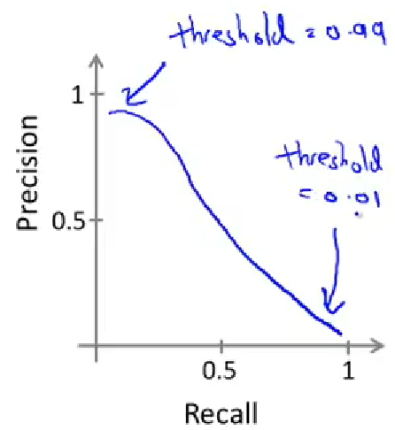

F1­ Score

* How to compare precision/recall numbers?
  + The average is not very good at evaluating these numbers because given 3 algorithms, we can end with the following situation.

|  |  |  |  |  |
| --- | --- | --- | --- | --- |
|  | Precision (P) | Recall (R) | Average | F1­ Score |
| Algorithm 1 | 0.5 | 0.4 | 0.45 | **0.444** |
| Algorithm 2 | 0.7 | 0.1 | 0.4 | 0.175 |
| Algorithm 3 | 0.02 | 1.0 | **0.51** | 0.0392 |

* + The 3rd algorithm essentially picks $y=1$ all the time, but has the highest average score. Thus, we use the F1 score as our metric $F_{1}=2\frac{PR}{P+R}$.
  + This is a better metric because the numerator takes the product of P and R, which means if either is drastically low, then the F1 score will be low.
  + There are two extremes to the F1 score:
    - or $R=0⇒F_{1}=0$
    - $P=1$ and $R=1⇒F_{1}=1$

**Data for Machine Learning**

* A study conducted in 2001 showed that given 4 different learning algorithms applied to the same problem, all the algorithms got much better as the amount of data collected increased.
* But collecting more data will only help under certain cases.

Large Data Rationale

* Assume features $x∈R^{n+1}$ has enough information to predict $y$ accurately.
  + Example: For breakfast I ate ___ eggs. When choosing within $\left\{two,too,to\right\}$, it is clear that $two$ is the right word.
  + Counterexample: Predicting housing price from only size ($ft^{2}$) and no other features. It is not clear how to do this.
  + Useful test: Given the input $x$, can an expert confidently predict $y$?
* Then we can use a learning algorithm with a lot of parameters (e.g. logistic/linear regression with many features, neural network with many hidden units, etc.).
  + These low bias algorithms mean $J_{train}\left(θ\right)$ will be small.
* If they use a very large training set, they will hopefully be unlikely to *overfit* (so low variance, and $J_{train}\left(θ\right)≈J_{test}\left(θ\right)$). This implies $J_{test}\left(θ\right)$ should be small.

**Week 7**

**Support Vector Machines**

**Optimization Objective**

* Modification of logistic regression.
$$h_{θ}\left(x\right)=\frac{1}{1+e^{-θ^{T}x}}$$

* In this model, in a training or testing example, if we want an output of $y=1$, we must have $θ^{T}x≫0$. Similarly, if we want an output near $y=0$, we must have $θ^{T}x≪0$.
* So, in the logistic regression cost, we can rewrite this as the following.
$$=-y\log\left(\frac{1}{1+e^{-θ^{T}x}}\right)-\left(1-y\right)\log\left(1-\frac{1}{1+e^{-θ^{T}x}}\right)$$

* If $y=1$ (want $z=θ^{T}x≫0$), we get the following curve.

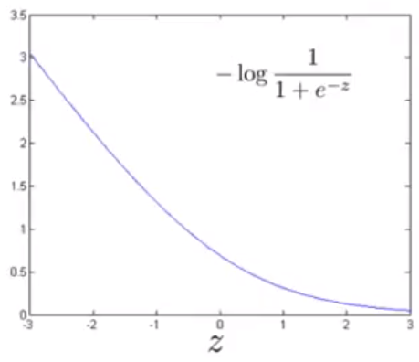

* This means that when logistic regression sees a positive example, it makes $θ^{T}x≫0$ to get near $y=1$.
* If $y=0$ (want $z=θ^{T}x≪0$), we get the following curve.

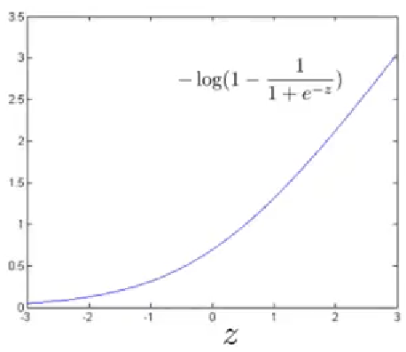

* This means that when logistic regression sees a positive example, it makes $θ^{T}x≪0$ to get near $y=0$.
* We then replace the blue line with a straight linear function that decreases, and when hits 0, remains constant. The same applies to the other activation function.

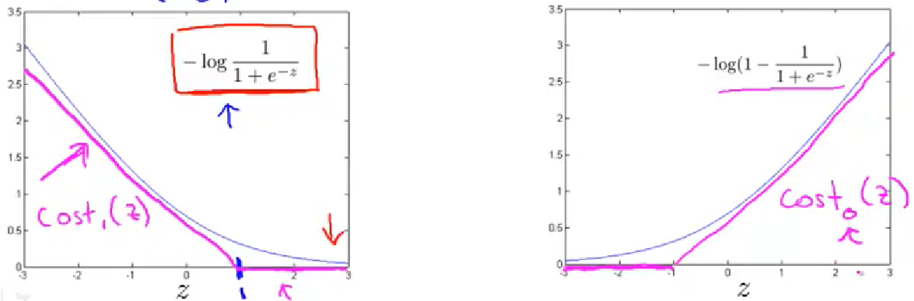

* Now we can build a support vector machine.
  + We have the following minimization problem for SVMs.
 $$\min_{θ}{\frac{1}{m}\sum_{i=1}^{m}{y^{\left(i\right)}cost_{1}\left(θ^{T}x^{\left(i\right)}\right)+\left(1-y^{\left(i\right)}\right)}cost_{0}\left(θ^{T}x^{\left(i\right)}\right)}+\frac{λ}{2m}\sum_{i=1}^{m}{θ_{i}^{2}}$$

 + However, we use a different convention for SVMs. We get rid of the $1/m$ term because it is simply a constant, so it doesn’t affect the optimal values of $θ$.
  + We also hold $λ$ constant and put a coefficient of $C=1/λ$ in front of the first term because that yields the same optimization objective.
  + Thus, we get the following cost function.
 $$\min_{θ}{C\sum_{i=1}^{m}{y^{\left(i\right)}cost_{1}\left(θ^{T}x^{\left(i\right)}\right)+\left(1-y^{\left(i\right)}\right)cost_{0}\left(θ^{T}x^{\left(i\right)}\right)}+\frac{1}{2}\sum_{i=1}^{m}{θ_{i}^{2}}}$$

 + The SVM makes the following hypothesis function.
$$h_{θ}\left(x\right)=\left\{\begin{aligned}1, if θ^{T}x≥0 \\ 0, otherwise \end{aligned}\right.$$

* To get an accurate classifier, there are 2 cases in minimizing the cost function.
  + If $y=1$, we want $θ^{T}x≥1$.
  + If $y=0$, we want $θ^{T}x≤-1$.

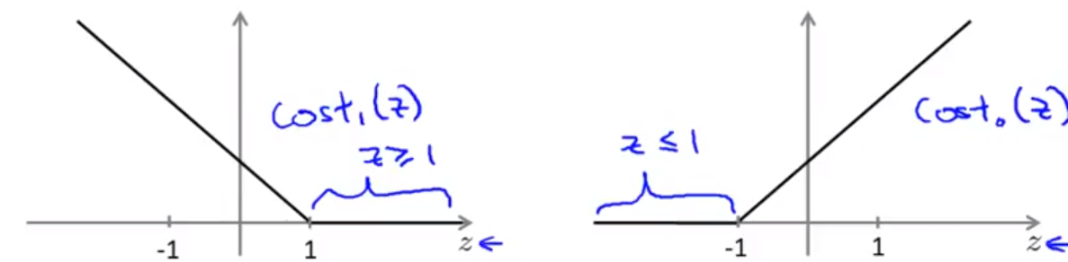

SVM Decision Boundary

* We set $C$ to be a large constant like $C=100,000$ so that we choose parameters $θ$ so the first term $C\sum_{i=1}^{m}{y^{\left(i\right)}cost_{1}\left(θ^{T}x^{\left(i\right)}\right)+\left(1-y^{\left(i\right)}\right)cost_{0}\left(θ^{T}x^{\left(i\right)}\right)}$ is close to 0. Then, we essentially have the optimization objective as follows.
$$\min_{θ}{C∙0+\frac{1}{2}\sum_{i=1}^{m}{θ_{i}^{2}}}$$

* Such that $θ^{T}x^{\left(i\right)}≥1$ if $y=1$ and $θ^{T}x^{\left(i\right)}≤-1$ if $y=0$.

SVM Decision Boundary: Linearly Separable Case

* An SVM is also called a **large margin classifier** because it separates linearly separable data with the largest possible margin for classification. This makes it quite robust.

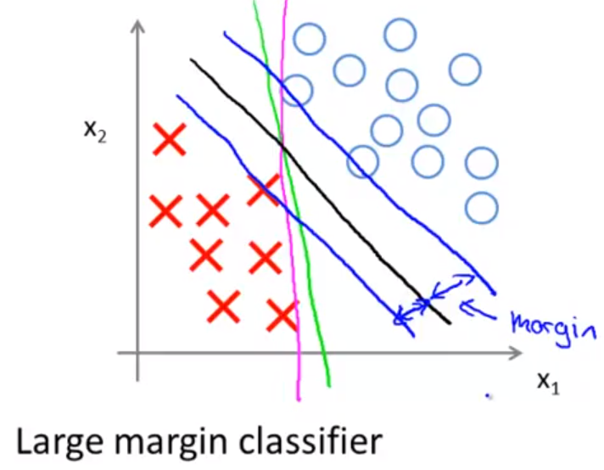

* This occurs when the regularization term $C$ is very large. However, this means that when we have an outlier, the SVM will its model drastically to fit the data well.

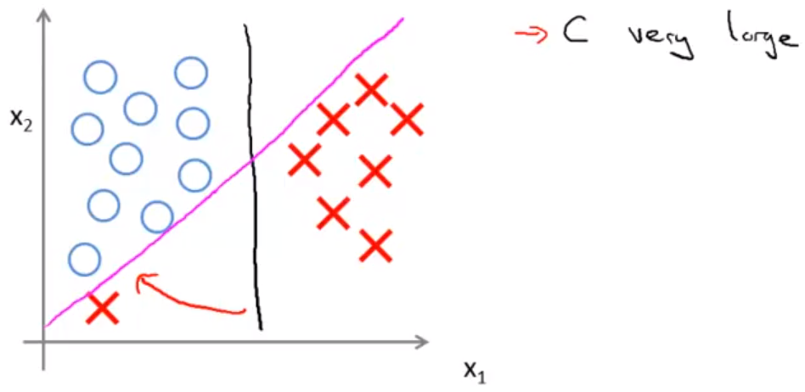

* However, if we choose $C$ not too large, we still end up with the black decision boundary.

**Mathematics of Large Margin Classification**

Vector Inner Product

* Given 2 vectors $u=\left[\begin{matrix}u_{1} \\ u_{2}\end{matrix}\right],v=\left[\begin{matrix}v_{1} \\ v_{2}\end{matrix}\right]$, the inner product is given as $u^{T}v={proj}_{u}\left(v\right)∙\left\|u\right\|=u_{1}v_{1}+u_{2}v_{2}$. Since ${proj}_{u}\left(v\right)=\left\|v\right\|\cos{θ}$, we get $u^{T}v=\left\|u\right\|\left\|v\right\|\cos{θ}$.

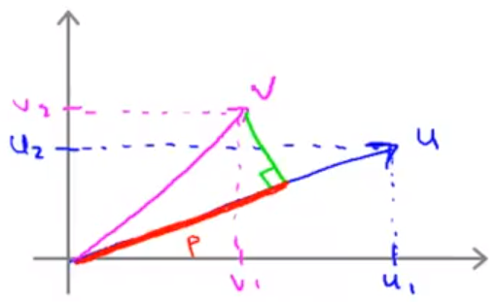

* The projection can be negative if the projection faces the opposite direction. (If angle between them is greater than 90°).
* Our optimization objective in the SVM is to find $\min{\frac{1}{2}\sum_{i=1}^{n}{θ_{i}^{2}}}$. Given the assumption $θ_{0}=0$ and if we have 2 parameter vectors, we simplify the optimization objective to $\min_{θ}{\frac{1}{2}\left(θ_{1}^{2}+θ_{2}^{2}\right)}=\min_{θ}{\frac{1}{2}{\left(\sqrt{θ_{1}^{2}+θ_{2}^{2}}\right)}^{2}}=\min_{θ}{\frac{1}{2}{\left\|θ\right\|}^{2}}$.
* Now we can explain what $θ^{T}x^{\left(i\right)}$ means. It means the projection of vector $x^{\left(i\right)}=\left[\begin{matrix}x_{1}^{\left(i\right)} \\ x_{2}^{\left(i\right)}\end{matrix}\right]$ onto the parameter vector $θ$. We label $p^{\left(i\right)}$ as the projection of the ith training example onto the parameter vector.

$$θ^{T}x^{\left(i\right)}=p^{\left(i\right)}∙\left\|θ\right\|=θ_{1}x_{1}^{\left(i\right)}+θ_{2}x_{2}^{\left(i\right)}$$

SVM Decision Boundary: Revisited

* We aim to find $\min_{θ}{\frac{1}{2}{\left\|θ\right\|}^{2}}$ such that
  + $p^{\left(i\right)}∙\left\|θ\right\|≥1$ if $y^{\left(i\right)}=1$
  + $p^{\left(i\right)}∙\left\|θ\right\|≤-1$ if $y^{\left(i\right)}=0$
* Where $p^{\left(i\right)}$ is the projection of $x^{\left(i\right)}$ onto the vector $θ$ (simplification $θ_{0}=0$– means decision boundary will pass through origin).
* The reason that a decision boundary (in green) and a parameter vector $θ$ cannot occur is because the projection of each training example onto the line is quite small, and we want $\operatorname{abs}\left(p^{\left(i\right)}∙\left\|θ\right\|\right)≥1$.

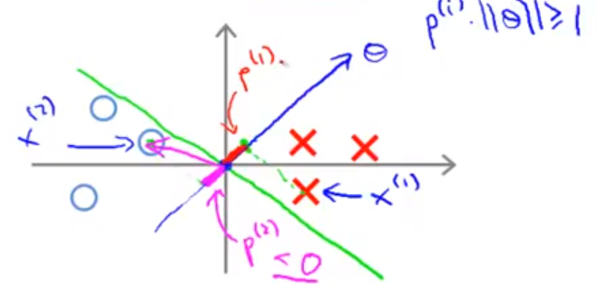

* Instead, the decision boundary ends vertical because the projections of each of the training examples is much larger.

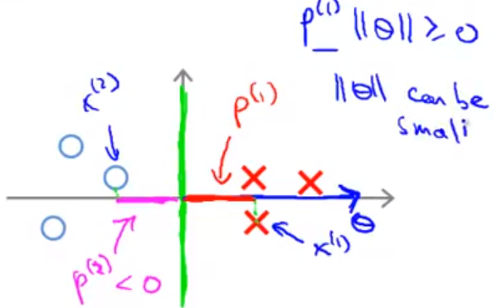

* So we have the large margin occurring that separates positive and negative examples. And this margin gap is the projection of each of the training examples onto the parameter vector $θ$.

**Kernels I**

Non-Linear Decision Boundary

* If we are given a non-linear decision boundary as below, we can come up with a number of features as below.

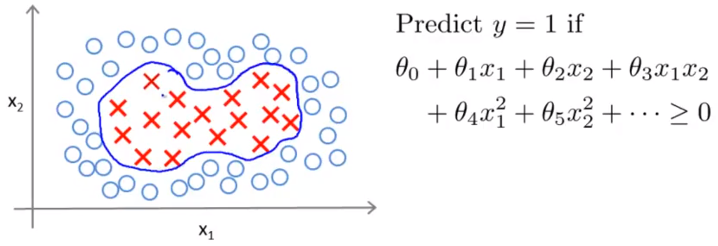

* We can use a new notation to represent each of the features.
$$h_{θ}\left(x\right)=θ_{0}+θ_{1}f_{1}+θ_{2}f_{2}+θ_{3}f_{3}+θ_{4}f_{4}+θ_{5}f_{5}+…$$

* $h_{θ}\left(x\right)$ is the decision boundary and $f_{1}=x_{1},f_{2}=x_{2},f_{3}=x_{1}x_{2},f_{4}=x_{1}^{2},f_{5}=x_{2}^{2}$ are features of decision boundary.
* But can we define a better way of coming up with these features $f_{1},f_{2},f_{3},…$?
* Given $x$, compute new feature depending on proximity to landmarks $l^{\left(1\right)},l^{\left(2\right)},l^{\left(3\right)}$.
  + Given $x$: $f_{i}=\operatorname{similarity}\left(x,l^{\left(i\right)}\right)=\exp\left(-\frac{\left\|x-l^{\left(i\right)}\right\|}{2σ^{2}}\right)$ for each $1≤i≤n$, where $n$ is the number of features.
  + We call these similarity functions kernels (specifically Gaussian kernels).
  + If $x≈l^{\left(i\right)}$, we get $f_{i}≈\exp\left(-\frac{0^{2}}{2σ^{2}}\right)≈1$.
  + If $x$ if far from $l^{\left(i\right)}$, we get $f_{i}≈\exp\left(-\frac{{\left(large \#\right)}^{2}}{2σ^{2}}\right)≈0$.
* Given landmarks $l^{\left(1\right)},l^{\left(2\right)},…,l^{\left(k\right)}$, we can create $k$ features $f_{1},f_{2},…,f_{k}$.

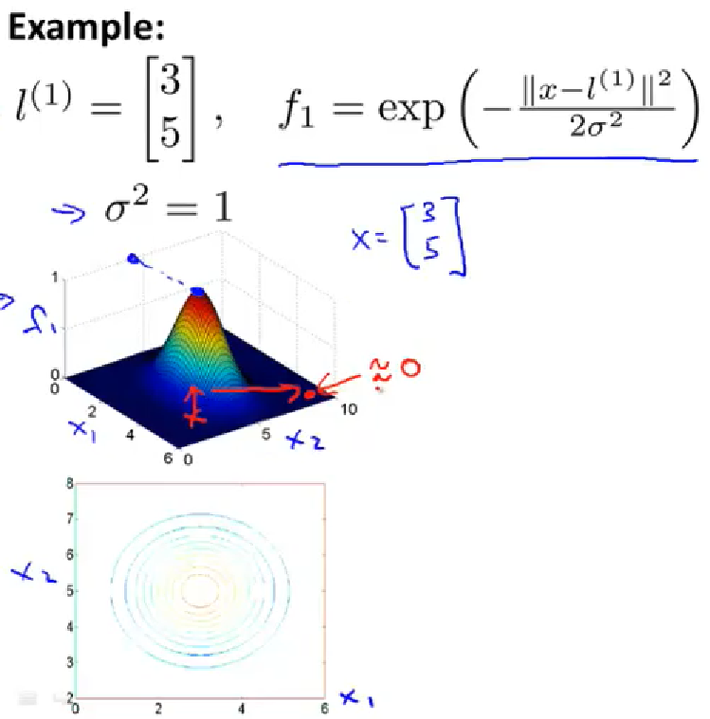

* The variable $σ^{2}$ basically determines the steepness of the cone of the exponentiation function. If $σ^{2}≈0$, the cone is extremely steep, and if $σ^{2}$ is large, the cone is flatter.

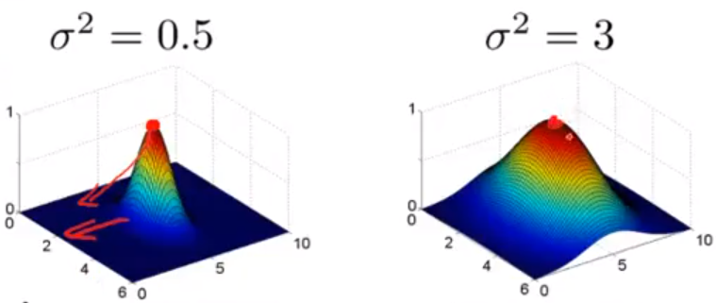

* Given values of $θ$ and the features, given a training example $x$, we can substitute those features to get the following.

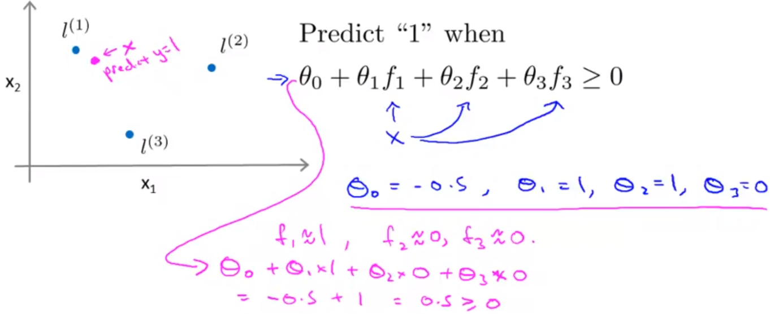

* These landmarks place a decision boundary (circular) around the 2 or 3 landmarks placed, creating a complex non-linear decision boundary.
* But how do we choose these landmarks? Can we use other similarity functions than the Gaussian kernel?

**Kernels 2**

* Given training examples $\left(x^{\left(1\right)},y^{\left(1\right)}\right),\left(x^{\left(2\right)},y^{\left(2\right)}\right),…,\left(x^{\left(m\right)},y^{\left(m\right)}\right)$, choose landmarks
 $l^{\left(1\right)}=x^{\left(1\right)},l^{\left(2\right)}=x^{\left(2\right)},…,l^{\left(m\right)}=x^{\left(m\right)}$

 + Thus, we then get the feature vector
 $$f=\left[\begin{matrix}\begin{matrix}f_{0} \\ f_{1}\end{matrix} \\ f_{2} \\ \begin{matrix}⋮ \\ f_{m}\end{matrix}\end{matrix}\right]$$

 + Thus, given a training example $\left(x^{\left(i\right)},y^{\left(i\right)}\right)$, we can compute the features as
 $$f_{1}^{\left(i\right)}=\operatorname{sim}\left(x^{\left(i\right)},l^{\left(1\right)}\right)$$

 $$f_{2}^{\left(i\right)}=\operatorname{sim}\left(x^{\left(i\right)},l^{\left(2\right)}\right)$$

$$⋮$$

$$f_{m}^{\left(i\right)}=\operatorname{sim}\left(x^{\left(i\right)},l^{\left(m\right)}\right)$$

+ We can then change each training example into a feature vector (where $f_{0}^{\left(i\right)}=1$)

$$f^{\left(i\right)}=\left[\begin{matrix}\begin{matrix}f_{0}^{\left(i\right)} \\ f_{1}^{\left(i\right)}\end{matrix} \\ f_{2}^{\left(i\right)} \\ \begin{matrix}⋮ \\ f_{m}^{\left(i\right)}\end{matrix}\end{matrix}\right]$$

SVM with Kernels

* First, given $x$, compute features $f∈R^{m+1}$. Then predict $y=1$ if $θ^{T}f≥0$, and $y=0$ otherwise, where $θ^{T}f=θ_{0}f_{0}+θ_{1}f_{1}+θ_{2}f_{2}+…+θ_{m}f_{m}$.
* And how do you find the parameter vector $θ$? Using the SVM optimization problem.
$$\min_{θ}{C\sum_{i=1}^{m}{y^{\left(i\right)}cost_{1}\left(θ^{T}f^{\left(i\right)}\right)+\left(1-y^{\left(i\right)}\right)cost_{0}\left(θ^{T}f^{\left(i\right)}\right)}+\frac{1}{2}\sum_{i=1}^{m}{θ_{i}^{2}}}$$

* Here, we simply use the features $f$ instead of the raw inputs $x$.

SVM Parameters

* + Large $C$: lower bias, higher variance (small $λ$) (overfitting).
  + Small $C$: higher bias, lower variance (large $λ$) (underfitting).
 $σ^{2}$

 + Large $σ^{2}$: Features $f_{i}$ vary more smoothly. Higher bias, lower variance (underfitting).
  + Small $σ^{2}$: Features $f_{i}$ vary more quickly. Lower bias, higher variance (overfitting).

**Using an SVM**

* Use an SVM package like liblinear, libsvm, etc. to solve for parameters $θ$.
* Need to specify choice of $C=1/λ$ and choice of kernel (similarity function). For example, you could choose
  + No kernel (“linear kernel”) – Predict $y=0$ if $θ^{T}x≥0$.
    - When $n$ is large and $m$ is small.
  + Gaussian kernel – Let $f_{i}=\exp\left(-\frac{{\left\|x-l^{\left(i\right)}\right\|}^{2}}{2σ^{2}}\right)$, where $l^{\left(i\right)}=x^{\left(i\right)}$. We need to choose $σ^{2}$.
    - When $x∈R^{n}$ and $n$ is small and/or $m$ is large.
  + Note: It is important to perform feature scaling before using the Gaussian kernel because this classifier is not **affine transformation invariant**.
  + Consider the term ${\left\|x-l^{\left(i\right)}\right\|}^{2}$ in the Gaussian kernel. This is equal to
 $${\left(x_{1}-l_{1}^{\left(i\right)}\right)}^{2}+{\left(x_{2}-l_{2}^{\left(i\right)}\right)}^{2}+…+{\left(x_{n}-l_{n}^{\left(i\right)}\right)}^{2}.$$

 + However, if $x_{1}$ is the feature of size (in 1000ft2) and is the feature of bedrooms (1 – 5), then feature $x_{1}$ can heavily skew the predictions.
  + Note: Not all similarity functions make valid kernels. They need to satisfy **Mercer’s Theorem** to make sure SVM packages’ optimizations run correctly.
  + There are other kernels people use too
    - Polynomial kernel $k\left(x,l\right)={\left(x^{T}l+A\right)}^{n}$, where $A∈R$ and $n∈N$.

Multi-Classification Problems

* SVM packages already have multi-class functionality. Otherwise, use one-vs-all method. (Train $K$ SVMs, 1 to classify each class, then pick class $i$ with maximum output ${\left(θ^{\left(i\right)}\right)}^{T}x$.
* For $n$ features and $m$ training examples, we have
  + $n$ is large 🡪 use logistic regression or SVM without a kernel (“linear kernel”)
  + $n$ is small ( $m$ is intermediate) 🡪 use SVM with Gaussian kernel
  + $n$ is small ( $m$ is large) 🡪 add more features, then use logistic regression of SVM without kernel (“linear kernel”)
* Neural network will also work well for these settings, but may be slower to train.